Try to reproduce the issue in Pre-Prod first in Scenarios 1) and 2) and then do same tests in System Test with Scenarios 3) and 4) to prove fix

PreProd Scenario 1) Same Dispute Type, different reasons

1st Dispute a 1201, 2nd dispute a 1202, 3rd Dispute a 1201

To reproduce the issue expect the 3rd dispute to incorrectly be grouped with 1st dispute.

**Result – Issue was reproduced**

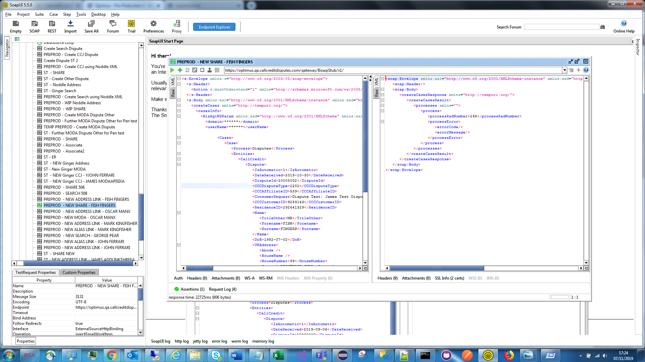

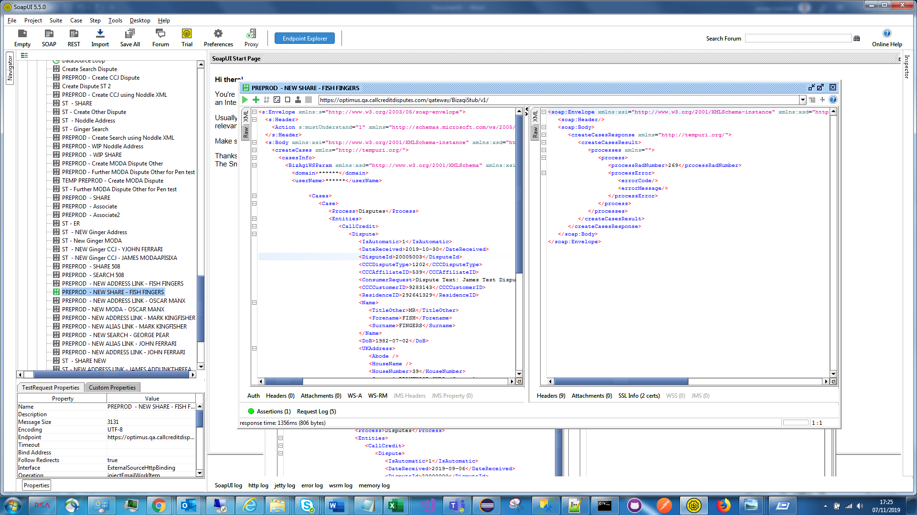

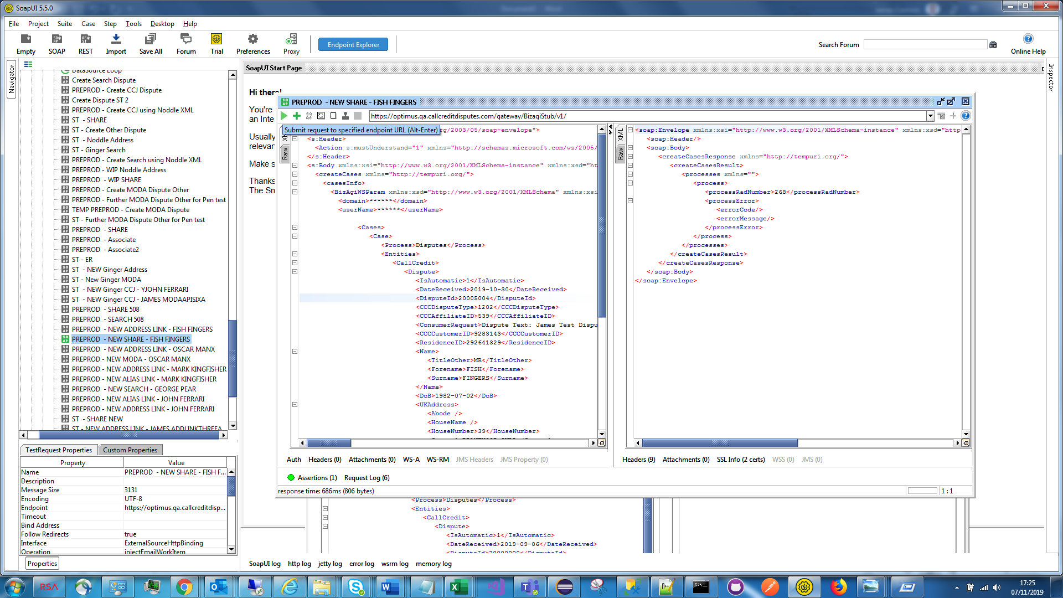

PreProd Scenario 2) Different Dispute Types

1st Dispute a 102 (Address), 2nd dispute a 803 (ER), 3rd Dispute a 803 (ER)

To reproduce the issue expect the 3rd dispute to incorrectly be grouped with 1st dispute.

**Result – Issue was reproduced**

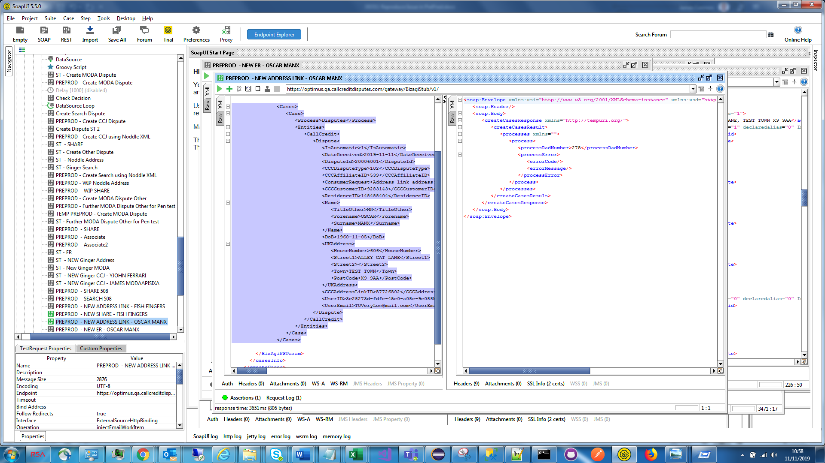

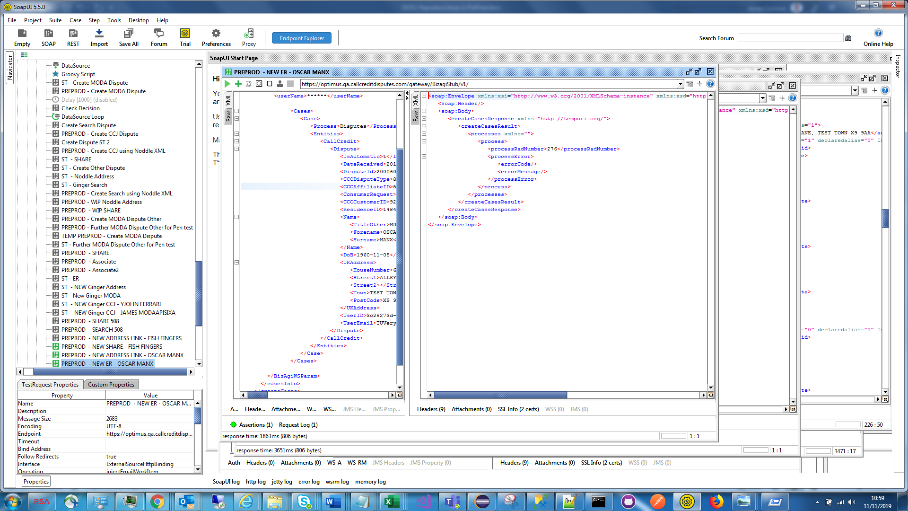

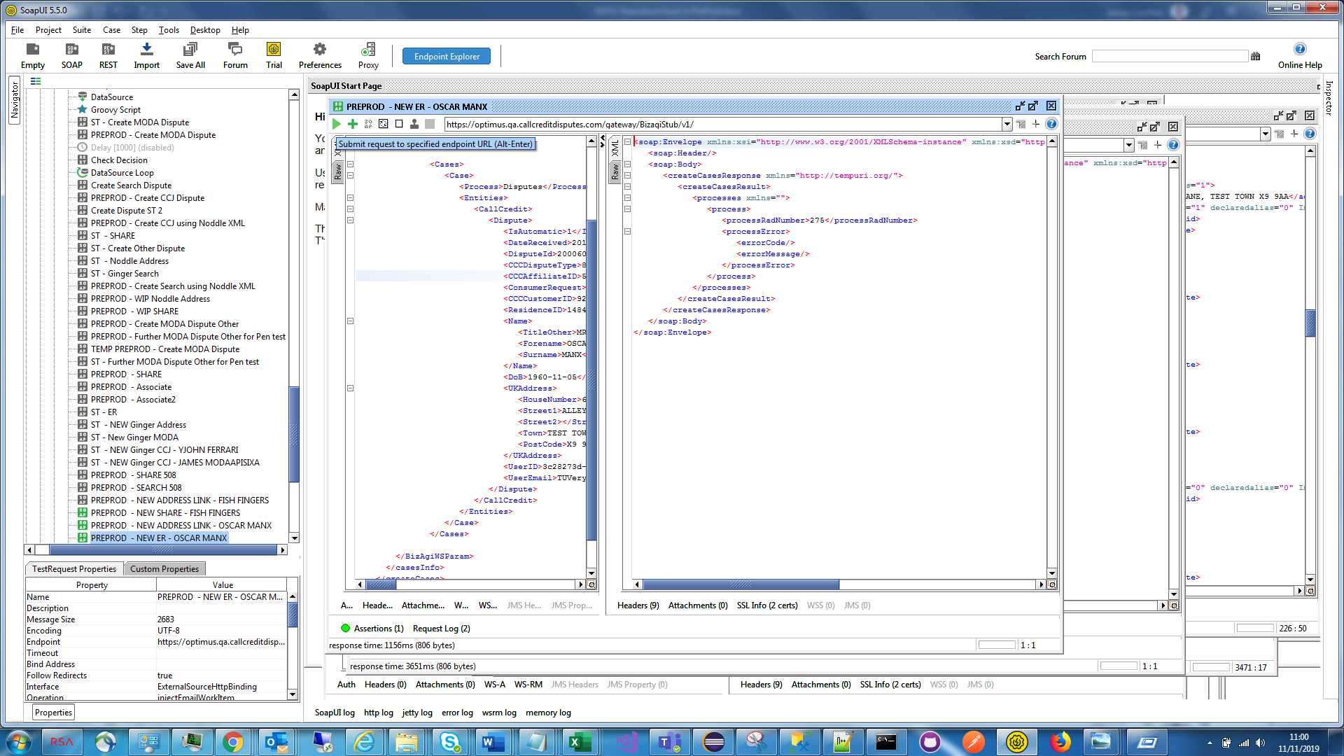

System Test Scenario 3) Same Dispute Types – same data as PreProd Scenario 1)

1st Dispute a 1201, 2nd dispute a 1202, 3rd Dispute a 1201

To prove the fix expect the 3rd dispute to correctly be grouped with 2nd dispute.

**Result – Fix proven**

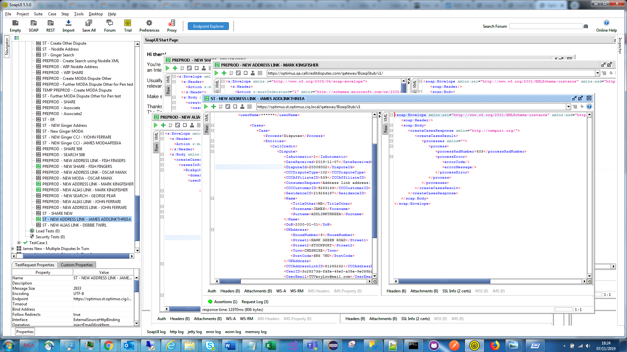

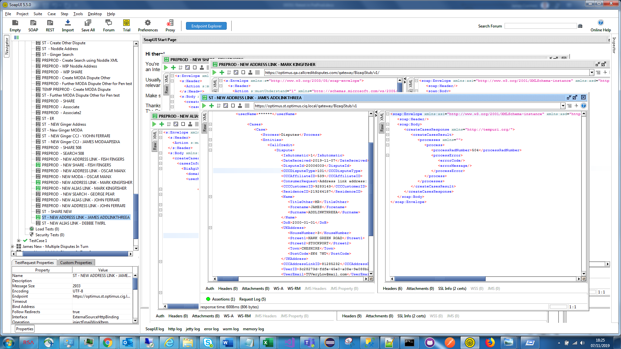

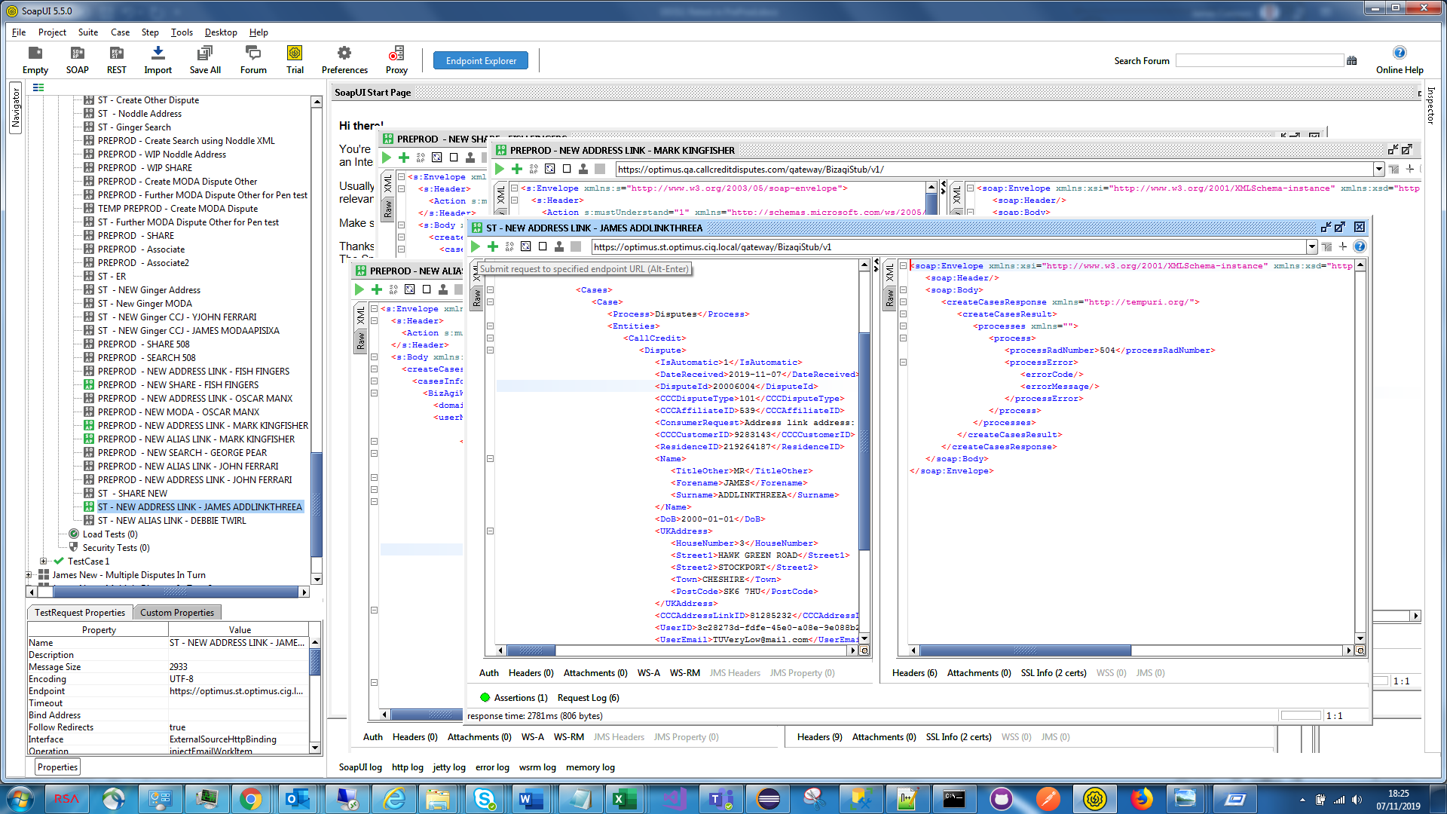

System Test Scenario 4) Different Dispute Types – same data as PreProd Scenario 2)

1st Dispute a 102 (Address), 2nd dispute a 803 (ER), 3rd Dispute a 803 (ER)

To prove the fix expect the 3rd dispute to correctly be grouped with 2nd dispute.

**Result – Fix proven**

